ZTE Customer Request Self-Service Portal User Manual V1.0.5

This document provides information about using ZTE Customer Request Self-Service Portal.
Website URL: http://support.zte.com.cn
Customer Request Self-Service Portal allows you to do the following tasks:
- Create requests, including Consultation, Incident, Problem, etc.
- Track the status of your requests
- Communicate with ZTE support engineers on the requests
- Close the requests and fill in the satisfactory survey

Contents
Contents 3
1. Introduction 4
2. Registration & Login 4
2.1. New User Registration 4
2.2. Logging in the Portal 5
3. Service Request 6
3.1. Creating a New Request 6
3.1.1. Requester Information 7
3.1.2. Request Information 7
3.2. Searching Requests 8
3.2.1. Request Status 9
3.2.2. Using Filters 9
3.2.3. Using Search Conditions 10
3.3. Viewing a Request 10
3.3.1. Viewing Basic Info 11
3.3.2. Viewing Process 11
3.3.3. Viewing Service Level Management 11
3.3.4. Viewing Service Report 11
3.3.5. Viewing Attachment 11
3.4. Processing Draft Requests 11
3.5. Appending Additional Information 12
3.6. Closing a Request 12
4. Trouble Ticket (TT) Case 13
4.1. Creating a New TT Case 13
4.2. Searching TT Cases 14
4.3. Viewing a TT case 15
5. My Information 16
5.1. Update My Information 16
5.2. Email Notification Configuration 16
5.3. Change Password 17

Introduction
To make the process of raising requests easier, ZTE Support website provides you with a Self-Service Portal where you can log your requests online with the help of a web-based form. Once you have submitted a request, it gets listed in your request view page, where you can keep track of the logged request. You can also update your personal information.
In the Self-Service Portal, there are following modules relevant to customer requests,
- Service Request: You can create a new request and view the same. Also all the requests that you have raised till date will be saved for future references.
- Trouble Ticket (TT) Case: You can search for solutions from the knowledge base for the issues that you are currently facing. If you cannot find any solution for the problem at hand, then you can post your issue as a request.
- My Information: You can view and update your account details including your password.

Registration & Login

New User Registration
Use the following procedures to register a new account,
- Open ZTE Support website URL: http://support.zte.com.cn.
- Click the registration entry in the upper right corner.
- Read through the agreement, if you agree with the statements, click Agree.
Then the new account registration form appears.
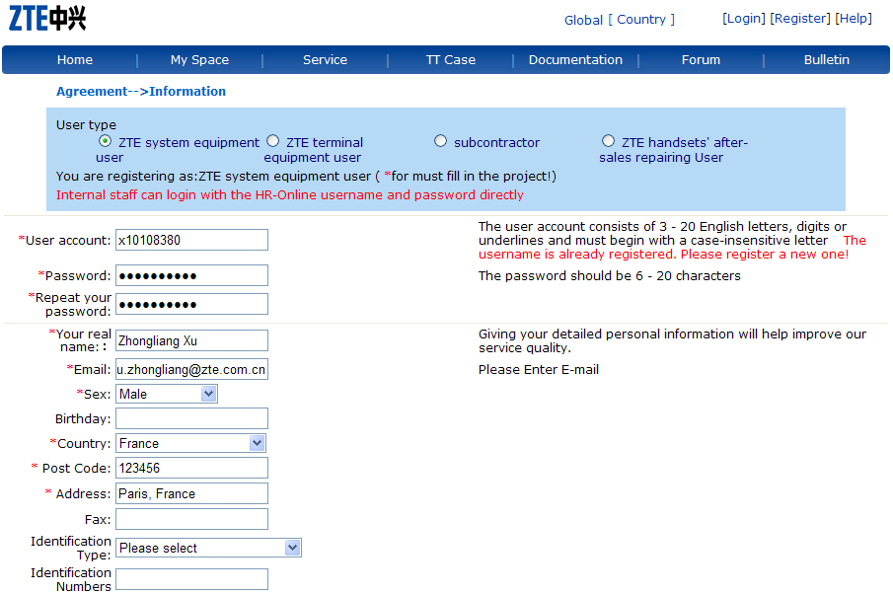
Choose a right user type and enter all the necessary fields, then click Submit.
The registration will be verified by ZTE in two working days. And you will receive corresponding email notifications.

Notes:
- ZTE system equipment user:
My company/organization has purchased ZTE products or services and my job is quite related to the products or services of ZTE.
- ZTE terminal equipment user:
I have purchased terminal products (ADSL Modem, WLAN, et.) of ZTE and want to get relevant technical support information.
- Subcontractor:
My company is a partner of ZTE and can provide services such as Turnkey project, telecom equipment installation and maintenance, etc.

Logging in the Portal
To log in to the self-service portal, enter the Support website URL in a browser.
The login form appears,
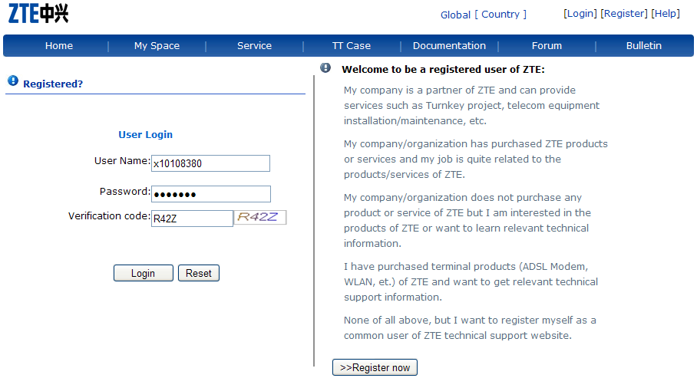
Enter your account name, password, and the random check code, click Login.

Notes:
All the Service Desk Express (SDE) accounts have been migrated into ZTE Self-Service Portal, which means you can log in to the portal with your former SDE accounts instead of registering a new one.

Service Request
The Support website provides you the service request module. Here, you can create new requests to post your queries, incidents, problems, etc. You can also view the requests that you have posted and keep track of their status.

Creating a New Request
When you need a service from ZTE Corporation, just send a request to ZTE. There are different modes of placing a request, such as web-based form, e-mail, phone call, etc. To create a new request using the web-based form,
- Log in to Support website with your user name and password.
- Click the ‘Service’ tab in the header pane.
- Click the ‘Service Request’ in the left navigation area.
- Click the ‘Create Service Request’ link expanded below.
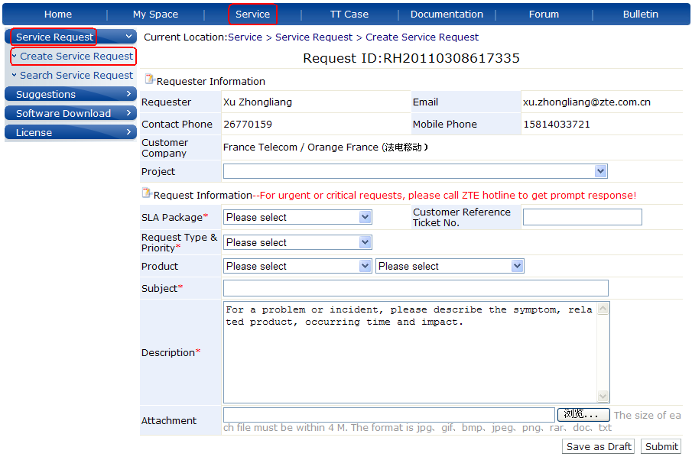

Requester Information
In this block, some of your basic information is displayed. The Requester Name, E-mail, Contact Number, Mobile Number, Customer Company is non-editable. Generally the Project and SLA is non-editable either. But you can select another project from the drop-down list if you join more than one project with ZTE, and SLA derives from the project contract.
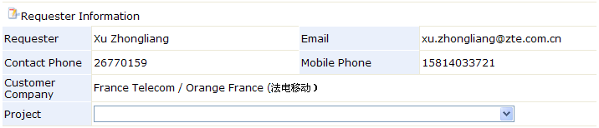

Request Information
- Customer Reference Ticket No.: If the customer company has its own ticketing system, this field can be used to refer to the ticket number in that system.
- Request Type & Priority: The selectable items in the drop-down list are defined in SLA between customer and ZTE. If there are no such definitions, ZTE standard options are loaded.
- Product: Select the product related to the request you are submitting.
- Subject: Title the request that will exactly summarize your request content.
- Description: Provide a detailed description for the request as per the template embedded in the text box.
- Attachment: Add related attachments to the request.
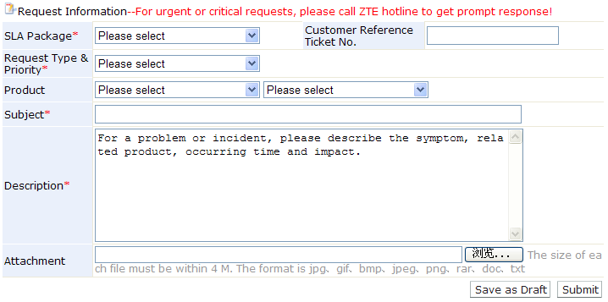
Fields with ‘*’ are mandatory. Once you have filled in all the necessary information, click the Submit button. The request will be submitted and some ZTE engineers are notified by email to process it. You can also choose to save the request temporarily for later processing and submission using ‘Save as Draft’.

Important Notes:
If you are making an urgent or critical request, it is recommended that you contact ZTE via hotlines to get prompt response!

Searching Requests
The Support website gives you an option to search for requests using filters and/or search conditions. As follows,
- Log in to Support website with your user name and password.
- Click the ‘Service’ tab in the header pane.
- Click the ‘Service Request’ in the left navigation area.
- Click the ‘Search Service Request’ link expanded below.
As you click the ‘Search Service Request’, all the requests within your authority get listed.
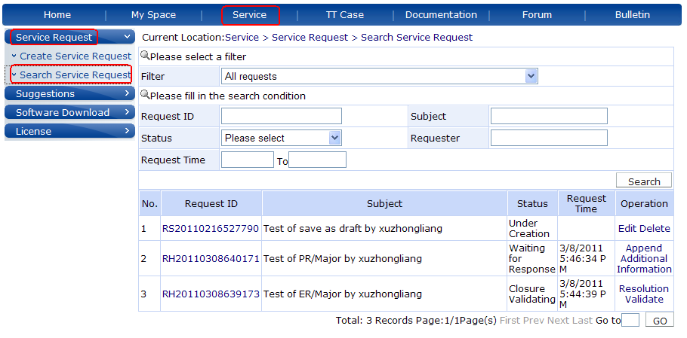

Notes:
There are two types of customer account, which are “Company-level” and “Personnel-level”.
- Company-level account
All SRs of his/her company can be viewed and handled by the company-level account.
- Personnel-level account
Only the SRs submitted by himself/herself can be viewed and handle by the personnel-level account.

Request Status
All requests are in the following status,
- Under Creation: All the requests that have not been submitted.
- Waiting for Response: All the submitted requests that have not been processed by supplier.
- Working in Progress: All the submitted requests that are being processed and not suspended.
- Pending Customer Action: All the requests that are suspended as waiting for customer action like information collection, or some other customer reasons.
- Closure Validating: All the requests that have been submitted for closure approval, ticket consolidation, and request cancellation or rejection.
- Closed: All the requests that have been closed, consolidated, cancelled or rejected.

Using Filters
You can apply various filters to the list and view only a specific group of requests that you would like to view. This filtering helps you focus on just the requests that you wish to look at.
Select the Filter Showing combo box. You can see the list of all filters. Select the filter from the list based on your priority.
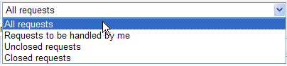
- All Requests: All the requests that have been created will be listed under this option.
- Requests to be handled by me: All the requests that have been assigned to you for processing will be listed under this option.
- Unclosed Requests: All the requests that have not been closed will be listed under this option.
- Closed Requests: All the requests that have been closed will be listed under this option.

Using Search Conditions
You can also search for requests with Request ID, Subject, Requester Name, Current Status, Request Time, etc. After entering some conditions, click the Search button, the requests that match the provided conditions will be listed.
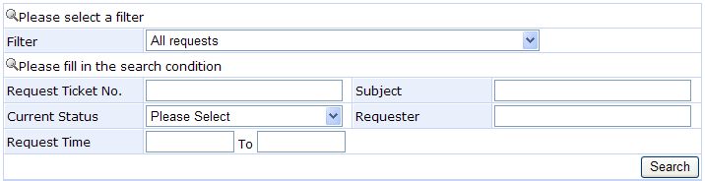

Viewing a Request
To view a request, click on the Request ID of the request that you want to view from the search result list. This opens the Request Details page. By default the page displays Information, Process, SLM, Service Report, and Attachment tabs.
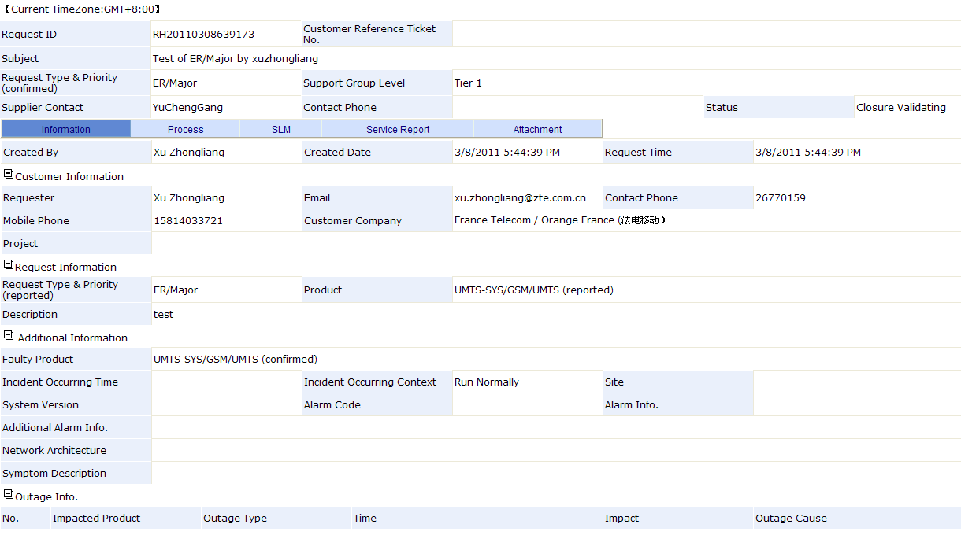

Viewing Basic Info
In the Information tab, the data are grouped in a logical manner. By default it displays the Requester Information, Request Information, Additional Information, etc.
On the top of the page above the tabs, the Request ID, Customer Reference Ticket Number, Subject, Request Type & Priority, Support Group Level, Supplier Contact are displayed
The Requester Information block displays Requester Name, E-mail, Contact Number, Mobile Number, Customer Company, Project.
In the Request Information block, the details of the request such as Request Type & Priority, Product, Request Description and Attachment name are displayed.
Next is the Additional Information block. It displays Faulty Product, Incident Occurring Time, and other relevant information for troubleshooting tickets. For technical query tickets, it contains less information.
Finally, it displays outages occurred in the Outage Info block.

Viewing Process
To view the processing logs, click the Process tab in the view request page. The details that displayed are in the descending order with the earliest performed action shown at the bottom of the page and the latest action at the top of the page.

Viewing Service Level Management
To view the fulfillment of SLA for the request, click the SLM tab in the view request page. Two blocks are displayed. One is the track of SLA fulfillment. It contains SLA ID, Service Targets, Due Date, Finish Date, Fulfillment Result, and Time excluded. The other block is about suspension. All suspensions are recorded here.

Viewing Service Report
To view the service reports for the request, click the Service Report tab in the view request page. Here you can find the interim and final reports corresponding to the SLA service targets.

Viewing Attachment
In the Attachment Tab, all the attachments uploaded are listed.

Processing Draft Requests
To continue to process the draft requests saved before, firstly you need to search them out. Then click on the operation link at the very right column of the search result list. You can click Edit to continue to edit the request before submission, or you can just delete it by clicking Delete.
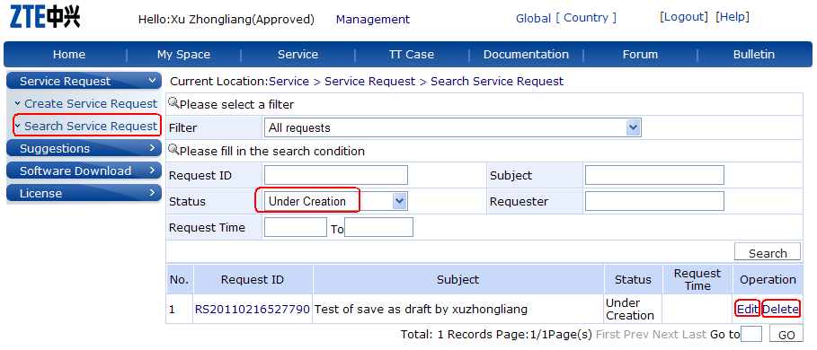

Appending Additional Information
If you want to make some comments on the request, answer questions, append some information or log files, or at any similar situation, you can use the ‘Appending Additional Information’ feature. Click on the Appending Additional Information link, enter information in the text area, and add the attachment if any, then click Submit.
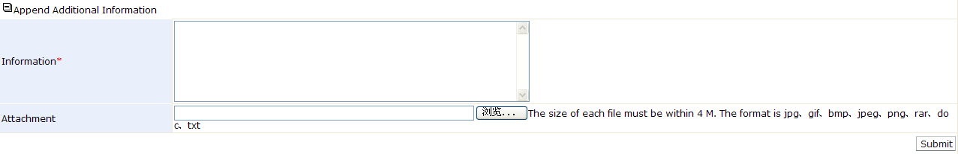

Closing a Request
When a request has been completely processed, usually as the resolution of the request has been provided and rolled out, the supporting engineer will submit the request for closure. The requester will be notified by email to validate it. You can click on the ticket link in the email to make the validation. Or you can click on the operation link in the request list.
If you confirm that the problem has been solved, and agree to close the ticket, choose ‘Solved’, rate the resolution and service attitude of the supporting engineers, and if you would like to make some more comments, enter them in the text area, and then click Submit.
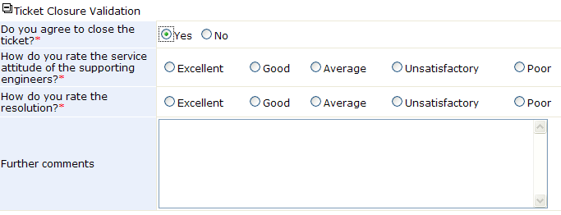
If you don’t agree to close the ticket yet, choose ‘Unsolved’, enter your opinion or comments in the text area, and then click Submit. The supporting engineer and customer support manager will be notified.
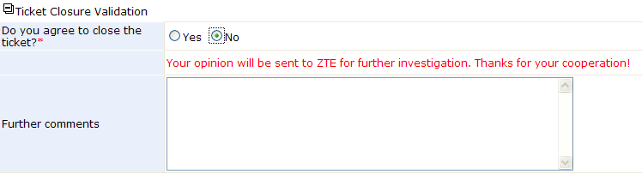

Trouble Ticket (TT) Case
The Support website gives a provision to add resolutions for all the requests that have been posted. These resolutions can be directly converted to knowledge base articles. Before you post a request, you can search for solutions specific to your problem. Thus, the TT Case serves as a knowledge base with resolutions for various problems.

Creating a New TT Case
You can add new TT cases to the existing knowledge base. To add new cases,
- Log in to Support website with your user name and password.
- Click the ‘TT Case’ tab in the header pane.
- Click the ‘Contribute Maintenance Experience’ in the left navigation area.
- Enter all the necessary fields.
- Click Submit. If you want to clear all the fields, click Reset.
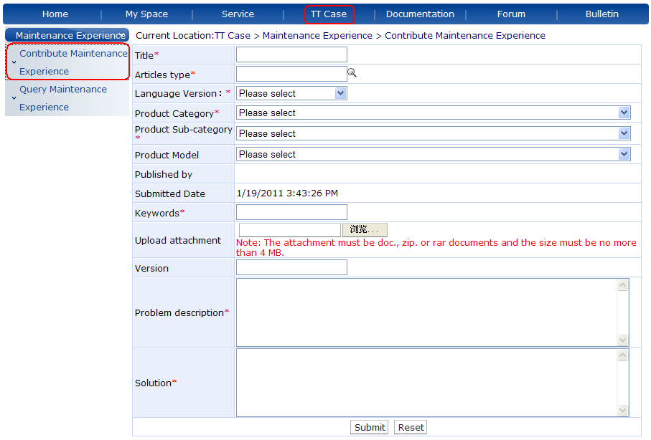
The Title, Articles Type, Language Version, Product Category, Product Sub-category, Keywords, Problem Description and Solution are mandatory fields. Product Model, Version and Attachment are optional.
As you have submitted the new case, it will be sent to the corresponding product expert for review. And after approval, it will be published in the knowledge base.

Searching TT Cases
TT Case allows you to search for solutions using search conditions. As follows,
- Log in to Support website with your user name and password.
- Click the ‘TT Case’ tab in the header pane.
- Click the ‘Query Maintenance Experience’ in the left navigation area.
- Enter the search conditions.
- Click the Search button, the list of cases corresponding to the search string gets displayed.
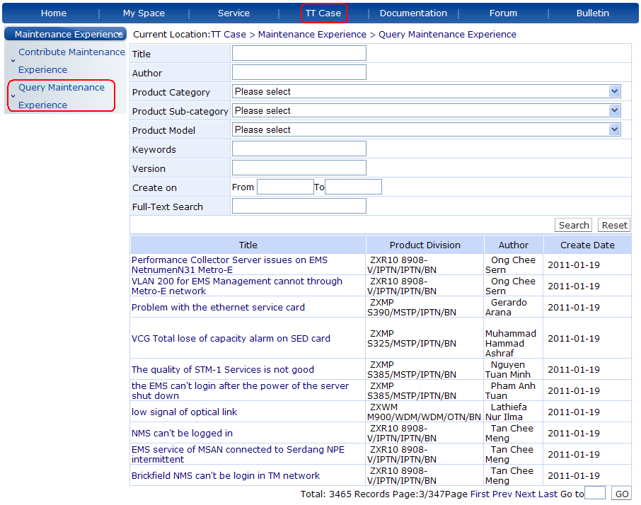

Viewing a TT case
To view the TT case details, click on the Title of the TT case that you want to view from the search result list. This opens the TT case details page. It displays the Problem Description, Solution, Attachment, and other basic information.
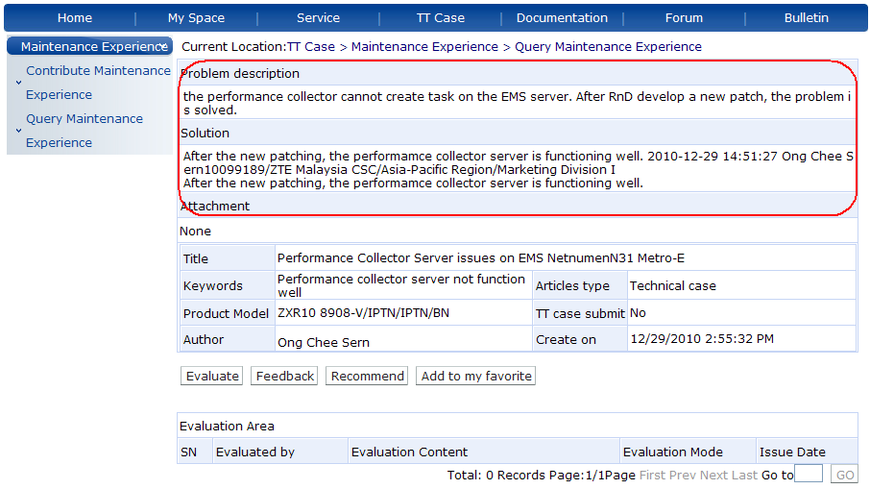

My Information
In the My Information section of My Space column, you are allowed to modify the information related to your profile including the password, which helps you maintain your profile updated with the latest changes.

Update My Information
The Support website enables you to modify your own profile whenever you want. To edit your profile,
- Log in to Support website with your user name and password.
- Click the ‘My Space’ tab in the header pane.
- Click the ‘My Information’ in the left navigation area.
- Click the ‘Update My Information’ link expanded below.
- Update the editable fields with your latest changes.
- When you are done with the modifications, click Submit.
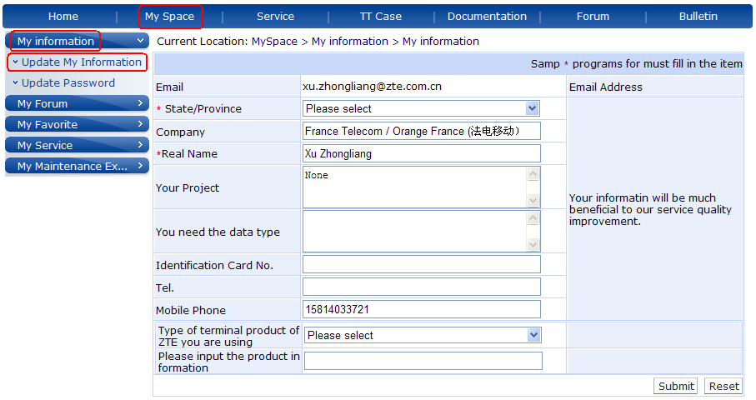

Email Notification Configuration
If you want to subscribe or cancel the email notifications relevant to your requests, you can use the following tick options.
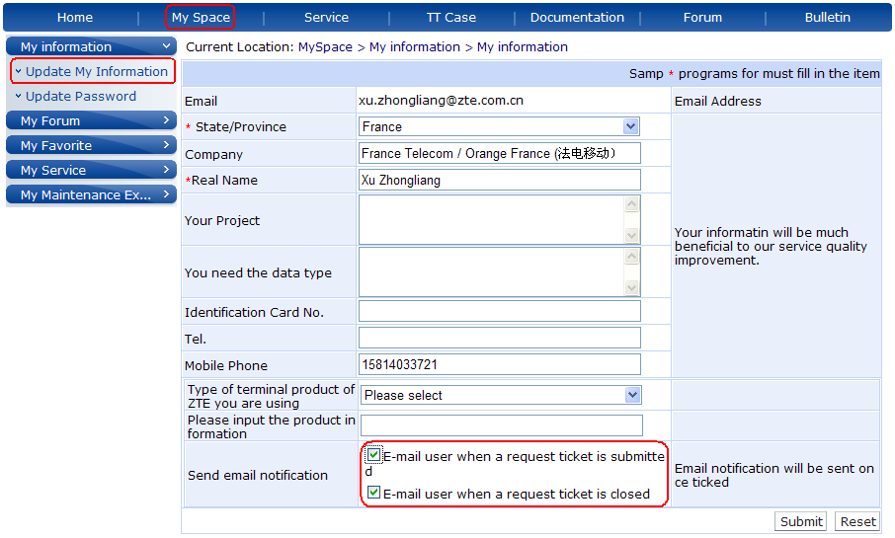

Change Password
To change your password, click ‘Update Password’ in the My Information view page, this opens the Change Password form, enter your old password and new password in the corresponding fields, and then click Submit.
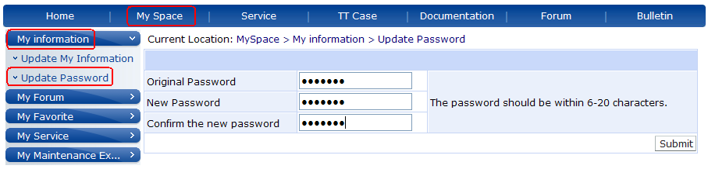

End of document

